Data modelling:- It represents the nature of data,business rules etc.
Types pf data modelling:-
Oltp ER Model
Olap Dimension Model
Oltp ER model
It contains attributes,action,Entity.
Eg
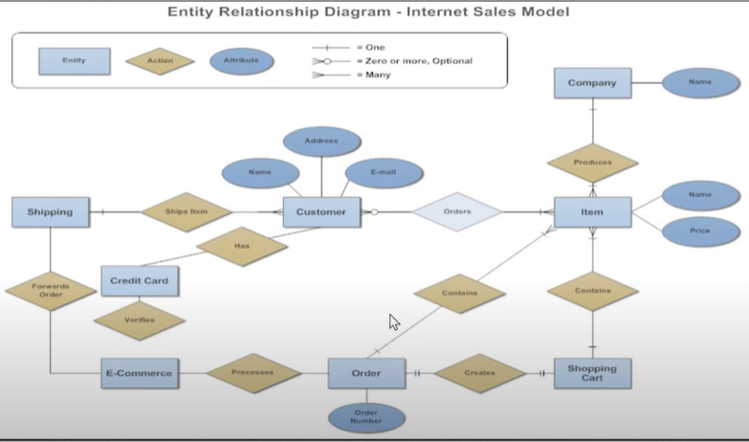
Olap dimension model is well explained in the word file of fact and dimension table.

Moving onto Schema
A structured way of representing Database.
Star Schema
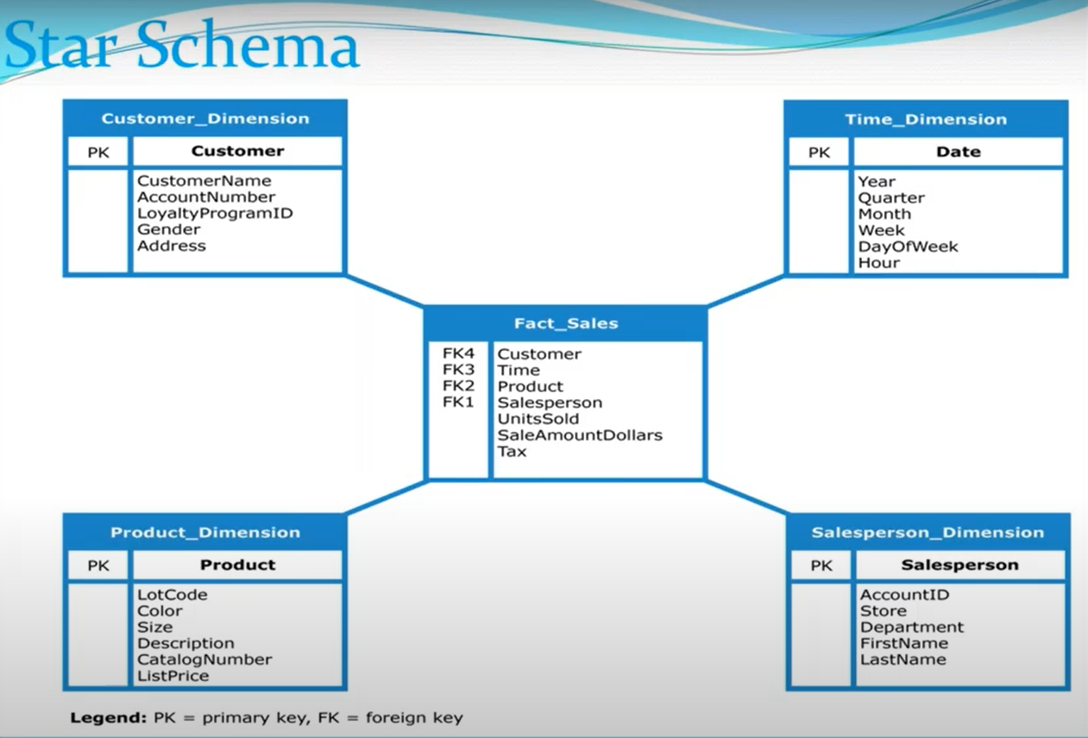
Benefits of Star schema:
Faster execution of queries
Demerit:-
Since the fact table is de normalized so duplication will affects the analysis of metadata.

Confusion:
Normalized vs Denormalized
Lamen terms
Normalized which doesnot contain foreign key. A table logically divided into Sub tables.
1NF ,2NF,3NF are types which means the original table data can be divided into a new table .
Original Dimension Table
New Table …………..1NF
New Table ……………. 2NF
New table …………… 3NF

Denormalized
Just refer to the first letter of denormalized ,which is d
D stands for duplication thus it contain foreign keys.
Denormalized is used to decrease number of tables as possible,but time limit execution on queries as no primary key of main table.
Snowfall schema
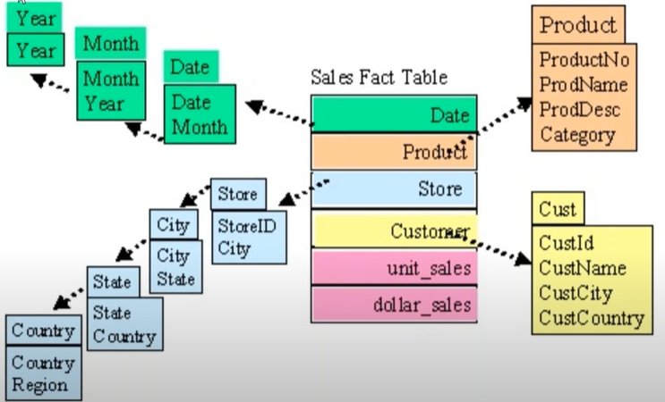
Demerits:-
Slower executions

Differences b/w star and snowfall schema
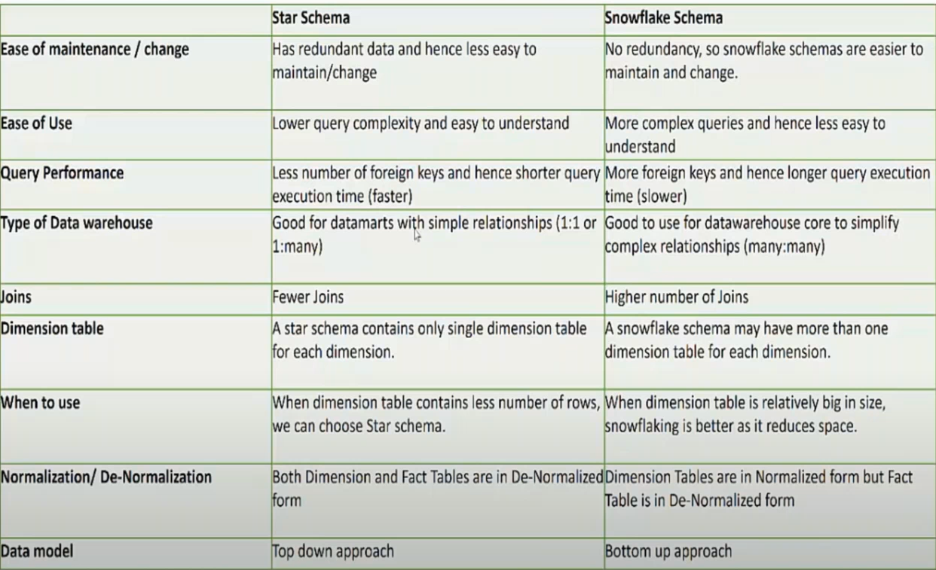
When to use
Star Schema:- Having Less Dataset size, less foreign key .
Snowfall:- Large Dataset size,more duplications ie foreign key.

Galaxy Schema
Combo of star and Snowfall ,rarely used .
--------------------------------------------------------------------------------------------------------------------------------------

Generalized step for data warehouse design
